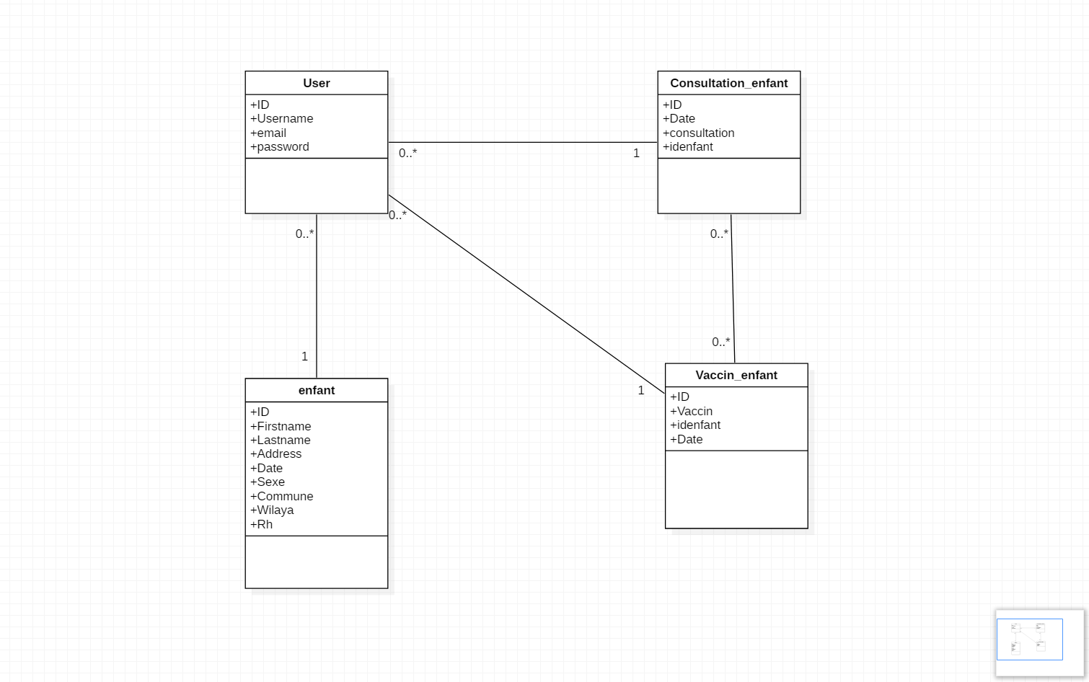

***Figure 1:*** *Diagramme de classe*

**2.2 Implementation**

For the implementation, the choice of programming language focused on the type of application which had to be implemented on the one hand, and be accessible via the University intranet on the other hand. Thus, the choice s is focused on web programming languages such as HTML, CSS, PHP and MySQL as a database server.

**2.2.2 Site plan :**

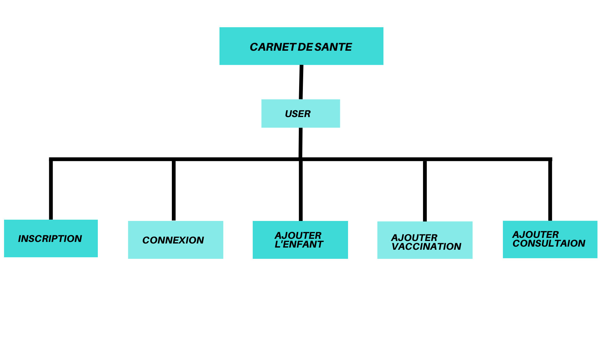

***Figure 2:*** Plan de site

**2.2.3 System interfaces**

|  |  |
| --- | --- |
| ***A) User home page***  **header home page** | **footer** |
| ***a)*** *Header home page* | ***b)*** *Footer home page* |

***The child's list***

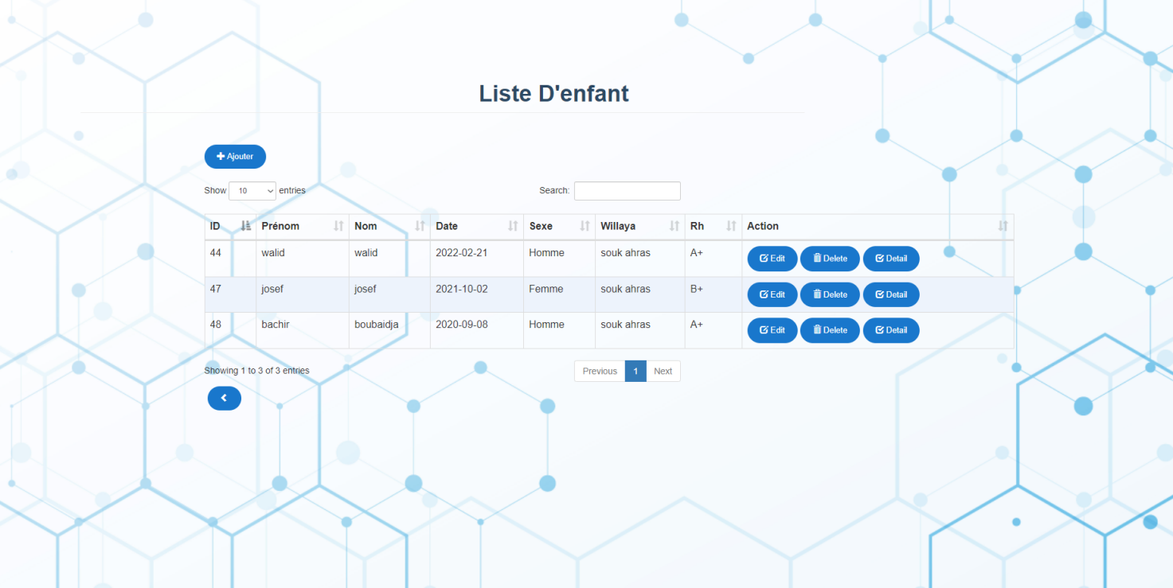

***Figure 4:*** *La liste d’enfant*

***B)Consultation and vaccination page***

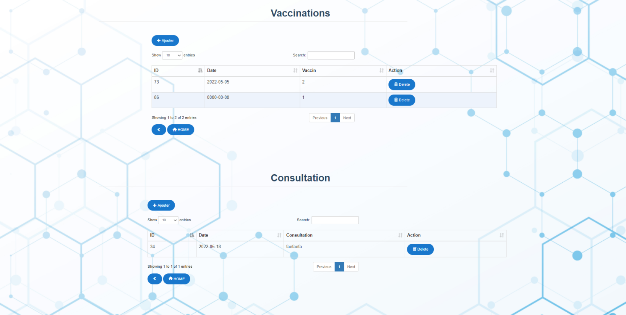

***Figure 5****: consultation list and vaccination*

***B)Connection interface***

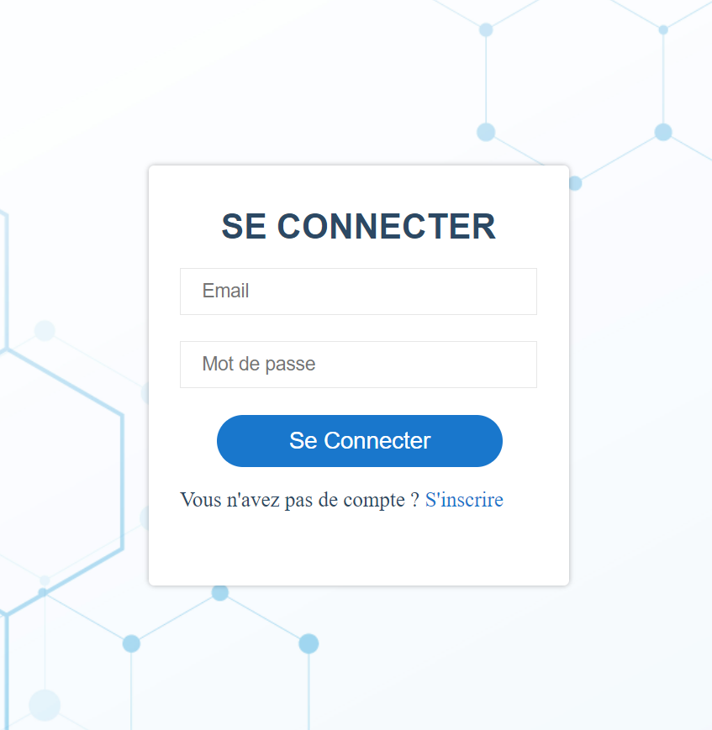

***Figure 6:*** *login page*